# 1. Introduction

Every organization, big or small, organizes events and has challenges to overcome, people, and operations to manage smoothly. From attendees to the location to the ambiance, there are many different areas in need of careful management. This application is being developed to override the problems prevailing the present manual systems. This system is being designed, keeping in mind the event requirements. This will reduce the struggle of maintaining groups, records of participants and payments, etc. Moreover, it will provide all the features with a user-friendly interface. The collection will be understandable and straightforward.

## 1.1 Idea and Purpose

We suggest an event particular app which will act as a common platform for serving different societies and clubs of an organization for easy and effective event management. This application will bridge the gap between the organizers and the attendees. The application will reduce the manual work significantly and allow easy management of participation.

# 2. Methodology

## 2.1 Existing Methods

Presently, the following methods are used to manage publicity and participations:

1. Flooding messages on WhatsApp and making groups of participants on WhatsApp to circulate messages require recording contact numbers of everyone and making sure that they read the previous messages.
2. Repetitive announcements in classrooms – often not possible to make in all classes.
3. Posters on notice boards – cluttering noticeboards with multiple posters, important notices go unnoticed.
4. Arranging meetings with the organizers to give payments – unreliable and causes confusion as people are often in different places.

## 2.2 Motivation

This system application’s motivation arose due to the current manual system problems, some of which are:

1. Very narrow span of attention towards long messages on WhatsApp.
2. Infrequent announcements disturb the environment of classes.
3. Wastage of resources in the form of paper and personnel.
4. Very time-consuming.
5. Difficulty in steady coordination and scheduling of different activities.

As participants and organizers, we feel that these problems cause confusion and a bad reputation.

## 2.3 Suggested Solutions

We suggest the following solutions to the above-discussed problems:

1. A common platform for organizers to handle records of the event.
2. Auto-ticket generation (QR).
3. A central database for storage of records.

## 2.4 Feasibility Study

An Assessment of the feasibility of the project.

**Economic Feasibility**

The project is economically feasible as it works with functions with low-cost services such as laptops and desktops.

**Technical Feasibility**

The current project is technically feasible as the application requires:

1. Any python supported IDE
2. Server-Side Services
3. GUI development tools

All these are readily available and can be successfully deployed on any available computer.

**Behavioural Feasibility**

The application is behaviourally feasible since it requires no technical guidance; all the modules are user friendly.

**Operational Feasibility**

The application is operationally feasible as:

1. Complete GUI-Base, which is user friendly.
2. Inputs to be taken are self-explanatory.
3. The system cuts down the load and cost of clients by high margins.

## 2.5 Software Requirement Specifications

Software Requirement Specification (SRS) is a description of a software system to be developed. It lays out functional and non-functional requirements and may include a set of use cases that describe user interactions that the software must provide. It establishes the basis for an agreement between customers and the software providers on what the software product is to do and what it is not expected to do so that there is no room for confusion in the future. If used appropriately, SRS can help prevent software project failure.

Our proposed system has the following requirements:

1. The system requires storing the information about a new participant being registered and, most notably, the event and its organizers.
2. The system needs to help the internal staff manage the entries of the database and keep information on activities.
3. The system needs to update, delete, and modify the records.
4. The system requires a search area and needs to maintain quality and quantity records.
5. The system requires the verification and authentication process of users.
6. The system needs to provide a QR code as identification to each participant at the time of registration.
7. The system should be able to provide as easy to read record of all participants and events.
8. Every participant should be able to enter an event just by showing the QR code that was provided at the time of registration.

# 3. Tools: Software and Hardware Requirements

## 3.1 Tools and Technologies

The following tools and technologies are expected to be used in development. Further may be added as the operations are implemented.

1. Language: Python
2. Database: MySQL, Excel
3. Libraries: Regex, Pillow, Tkinter, OpenCV

## 3.2 Hardware Requirements

The following hardware requirements are recommended to be fulfilled in order to run this software.

1. CPU: Intel core i3 3rd Generation / AMD FX-6100
2. RAM: 2 GB
3. GPU: Integrated Graphics
4. Storage: 1 GB
5. Camera: Any 3MP camera

## 3.3 Software Requirements

The following software requirements are recommended to be fulfilled in order to run this software.

1. OS: Any Operating System
2. Database: SQL
3. Programming Language: Python

# 4. System Design

## 4.1 Use Case Diagram:

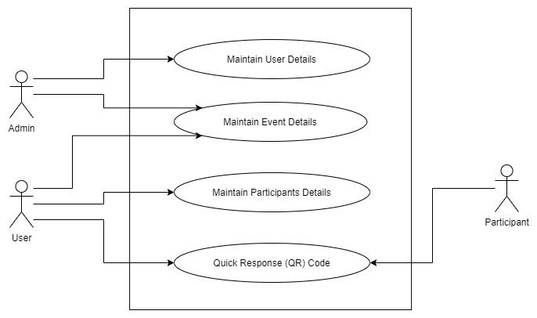

## 4.2 Flow Chart:

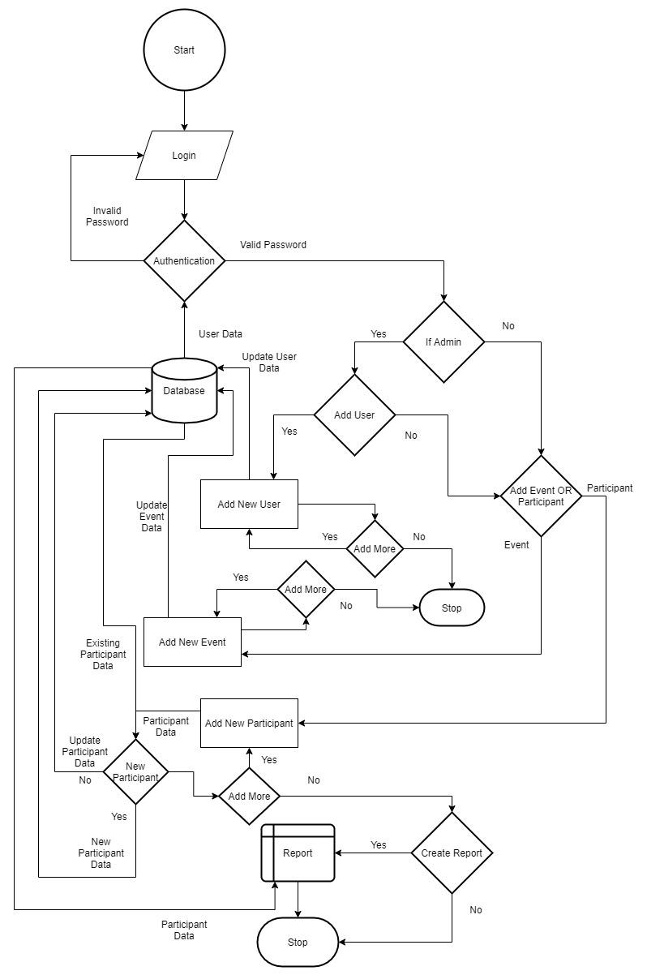

## 4.3 Entity Relationship Diagram:

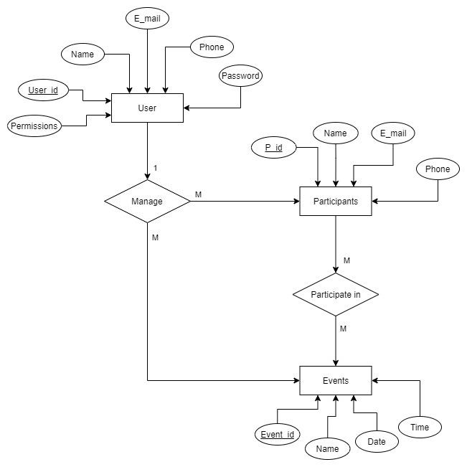

## 4.4 Database Tables Diagram:

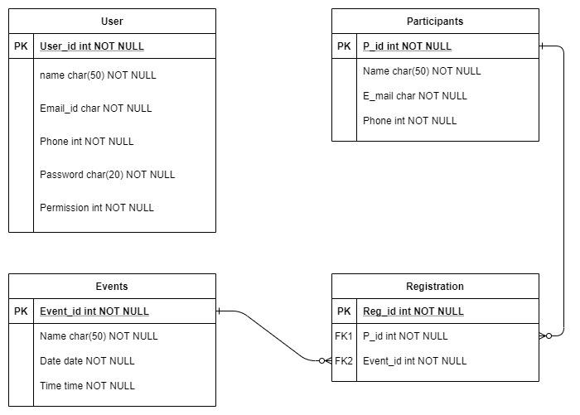

## 4.5 Data Flow Diagram (DFD):

**Level 0:**

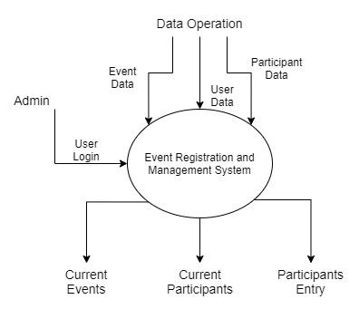

**Level 1:**

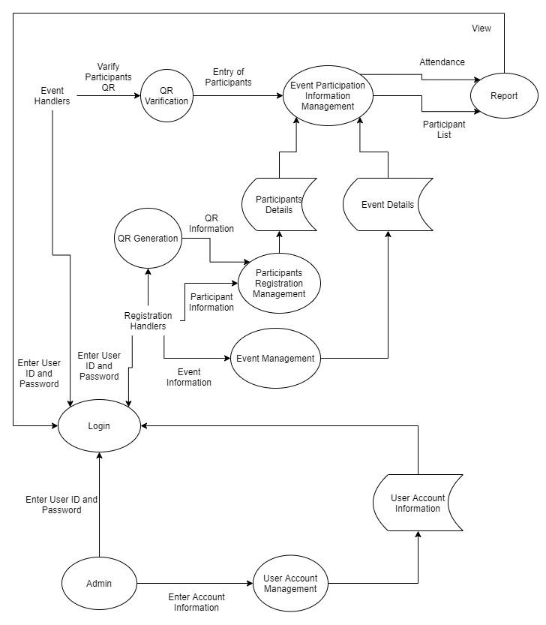

**Level 2:**

User Account Information Management:

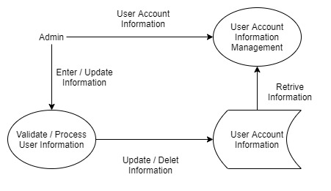

Login:

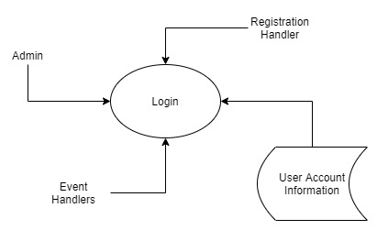

Participant Details Management:

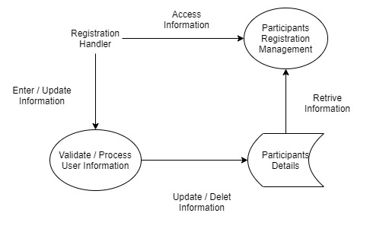

Event Details Management:



Event Participation Information Management:

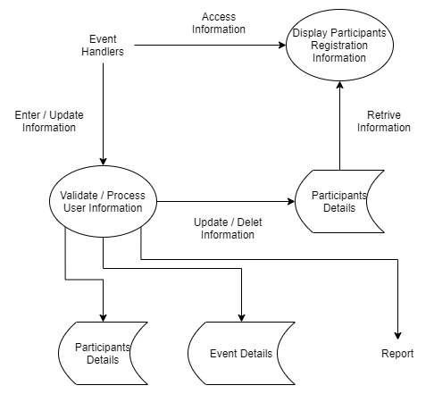

# 5. Future Scope

As of now, this project is a desktop application. The participants have to reach out to the registration desk to register themselves. In the near future, this application could be redesigned as a web-based application to make online registrations possible. This will reduce the waiting time of participants standing in line to register. This will make the registration process easier for the participant and encourage more people to participate.

# 6. Conclusion

The application would provide a simple and better way to organize events and manage participation. We hope it would ease the hassle of arranging payments, making groups, and all the effort it takes to manage public operations.